23.30:(a) 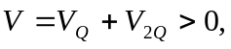 so V is zero nowhere except for infinitely far from the charges.
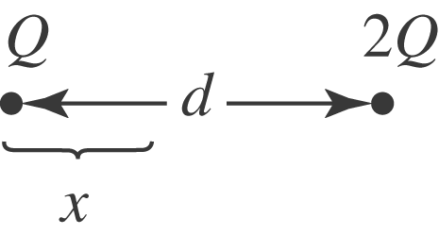 The fields can cancel only between the charges
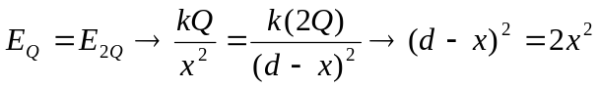
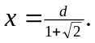 The other root, 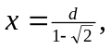does not lie between the charges.
(b)
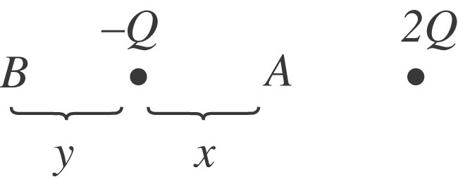 V can be zero in 2 places, A and B.

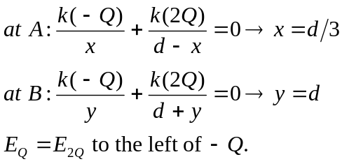
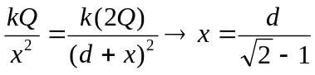

(c)
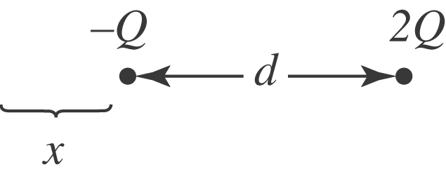 Note that E and V are not zero at the same places.

